Smart QR-Based Attendance Management System
A Project Based Learning Report Submitted in partial fulfilment of the requirements for the award of the degree

of

Bachelor of Technology
in The Department of CSE
FULL STACK APPLICATION DEVELOPMENT / 24SDCS02A

Submitted by
2410030339: BADDAM KARTHIK REDDY
2410030337: KASARLA MANI VARDHAN REDDY
2410030140: CHELLAMLLA JASWANTH REDDY
2410030146: SHAIK MUZAMMIL AHMED

Under the guidance of
Dr. Madhukar Rao Sir



Department of Computer Science and Engineering
Koneru Lakshmaiah Education Foundation, Aziz Nagar
Aziz Nagar – 500075
FEB - 2025.

Introduction
(Minimum 200 words)

- The traditional method of taking attendance in educational institutions has long been a time-consuming process that often leads to inefficiencies and inaccuracies. Teachers spend valuable class time calling out names, and students sometimes exploit the system through proxy attendance. In today's digital age, there's a pressing need for a more efficient, secure, and automated solution to this everyday problem.

- Our project, the Smart QR-Based Attendance Management System, addresses these challenges by leveraging modern web technologies to create a comprehensive attendance tracking solution. The system utilizes dynamically generated QR codes that refresh every 20 seconds, making it virtually impossible for students to share codes or mark proxy attendance. Combined with multiple layers of validation including device registration, GPS location verification, and IP subnet checking, the system ensures that attendance can only be marked by students who are physically present in the classroom.

- Built using Java Spring Boot for the backend and React.js for the frontend, this full-stack application demonstrates the practical implementation of modern software development principles. The project incorporates industry-standard security practices such as JWT authentication, device fingerprinting, and geolocation validation. What sets our system apart is its realistic approach to GPS validation—instead of rigidly rejecting students based on GPS accuracy issues common in buildings, we've implemented a confidence-based system that allows attendance within a 100-meter radius while flagging entries between 30-100 meters for teacher review.

- The motivation behind this project stems from observing the daily struggles faced by both teachers and students in the attendance process. We wanted to create a solution that not only saves time but also provides administrators with detailed analytics and reporting capabilities. The system maintains a complete audit trail of all attendance records, including timestamps, device information, and location data, which can be invaluable for administrative purposes.

- Throughout this project, we've focused on creating a production-ready system that can be actually deployed in a college environment. This means addressing real-world challenges like HTTPS requirements for geolocation APIs, handling mobile data connectivity issues, and creating an intuitive user interface that works seamlessly on both desktop and mobile devices. The project also emphasizes proper software engineering practices including comprehensive validation, error handling, and user feedback mechanisms that make the system robust and user-friendly.

METHODOLOGY/ IMPLEMENTATION
(Minimum 1200 words)

- The Smart QR-Based Attendance Management System is designed to automate the attendance process in educational institutions using QR technology and a secure web-based architecture. The methodology focuses on eliminating manual attendance procedures while ensuring security, accuracy, and ease of use.
- The proposed system replaces the traditional roll-call method with a digital attendance mechanism. Instead of calling out student names, instructors generate a dynamic QR code during the class session. Students present in the classroom scan the QR code using the attendance portal. The backend server then verifies the request through several validation layers before marking the attendance.
- The methodology ensures that attendance can only be marked by students who are physically present in the classroom. Multiple security mechanisms such as device registration, IP validation, and location verification help prevent proxy attendance.
- The overall methodology follows a structured process. First, the instructor logs into the faculty dashboard and starts an attendance session. When the session begins, the system generates a dynamic QR code which is displayed on the instructor’s screen. The QR code is temporary and refreshes periodically to prevent misuse.
- Students log into the student portal and navigate to the QR attendance scanner page. Before scanning the QR code, the system verifies the student's environment using a pre-scan checklist which ensures that the student is connected to the campus Wi-Fi network, mobile data is disabled, and location services are enabled.
- After the QR code is scanned, the encoded session token is sent to the backend server. The backend then performs authentication and validation checks. If all conditions are satisfied, the attendance record is stored in the database along with the timestamp, student ID, and session details.
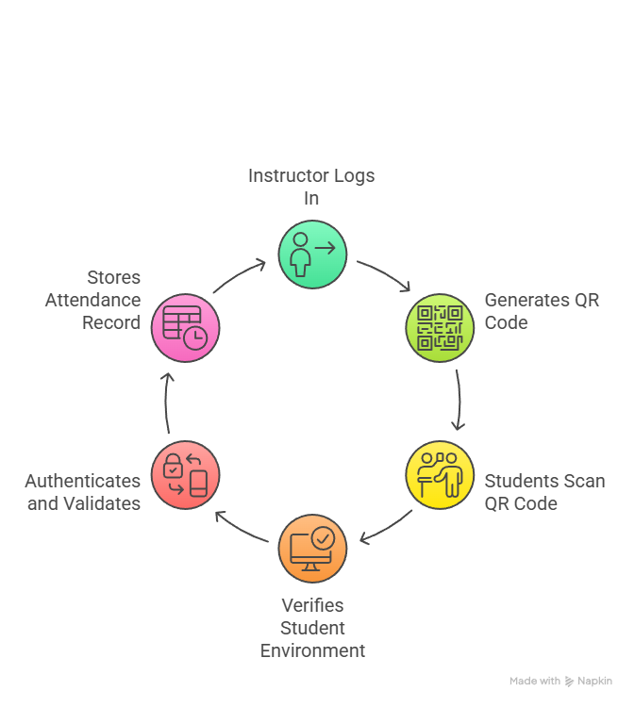

System Architecture
- The proposed system follows a three-tier architecture consisting of the presentation layer, application layer, and database layer.
- The presentation layer represents the frontend interface of the application. It is developed using modern web technologies and provides interfaces for both students and faculty members. The frontend allows users to log in, scan QR codes, view attendance data, manage devices, and access reports. The user interface has been designed to be responsive and intuitive so that users can interact with the system easily.
- The application layer is implemented using Java Spring Boot. This layer handles all the core logic of the system including authentication, QR code generation, validation processes, attendance recording, and data management. RESTful APIs are used for communication between the frontend and backend.
- The database layer stores all persistent data related to the system. A relational database such as MySQL is used to store student records, faculty details, registered devices, attendance logs, and session information. Proper indexing and relational design ensure efficient data retrieval and management.
- This layered architecture improves scalability, maintainability, and security of the system.
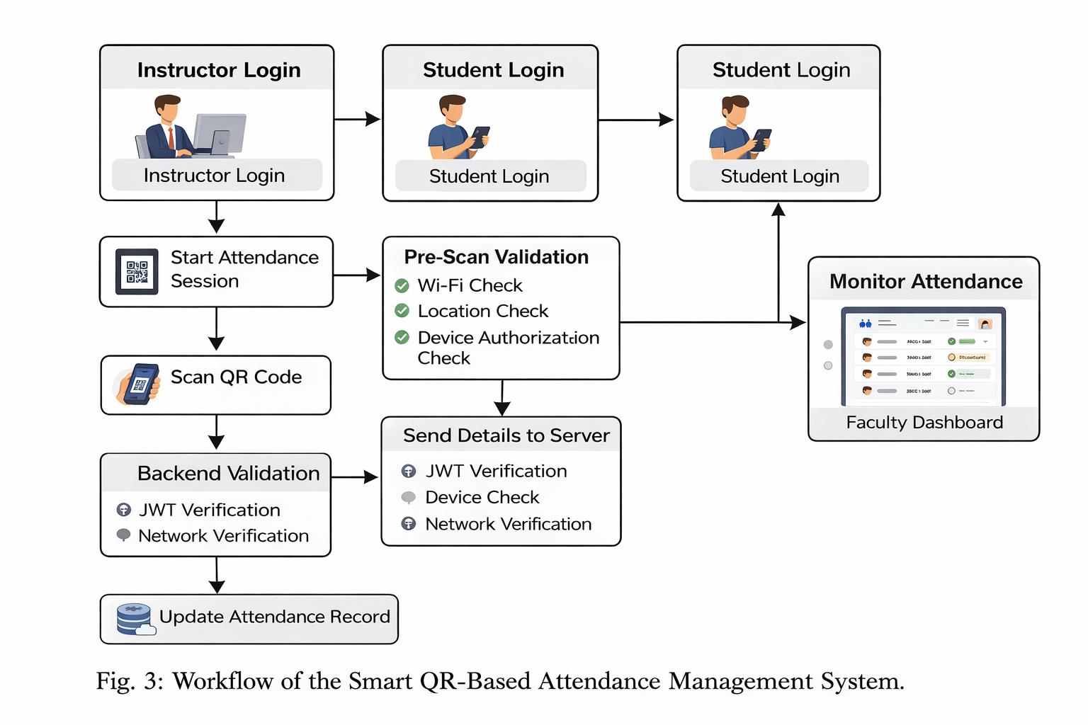

Implementation
- The implementation of the Smart QR-Based Attendance System is divided into multiple modules that collectively provide the full functionality of the application.
- The authentication module handles login and session management. Users authenticate using their university credentials, and the system generates a JWT token for secure communication.
- The student dashboard module provides students with an overview of their attendance statistics. It displays overall attendance percentage, classes attended, attendance streak, and upcoming schedules.
- The QR scanning module is the core component of the system. Students access the scanner page and scan the QR code generated by the instructor. The scanner captures the encoded session token and sends it to the backend for validation.
- The faculty dashboard allows instructors to manage attendance sessions. Instructors can start attendance sessions, generate QR codes, and view attendance records in real time.
- The attendance monitoring module displays student attendance status including present, absent, or flagged entries that require review.
- The attendance override module allows faculty members to manually update attendance records in case of technical issues or exceptional circumstances.
- The reporting module allows both students and faculty to view historical attendance data and export reports in CSV format.

Technologies Used
- Frontend Technologies:
HTML, CSS, JavaScript, and modern UI frameworks were used to design the responsive user interface. The frontend provides pages such as login, dashboard, QR scanner, attendance history, and device management.
- Backend Technologies:
The backend is implemented using Java Spring Boot which provides REST APIs, authentication mechanisms, and business logic implementation.
- Security Technologies:
JSON Web Tokens (JWT) are used for secure authentication. Additional security measures such as device verification and network validation are implemented to prevent unauthorized attendance marking.

Advantages of the Proposed System
- The Smart QR-Based Attendance Management System offers several advantages over traditional attendance systems.
- The system saves valuable class time by eliminating manual roll calls. Attendance can be recorded within seconds using QR scanning.
- The system prevents proxy attendance by implementing multiple validation mechanisms.
- Students can track their attendance performance through the dashboard which increases transparency.
- Faculty members can generate reports and monitor attendance records efficiently.
- The system is scalable and can be implemented across multiple departments and courses within the institution.

